St Nicholas of Tolentino RC Church, Lawford’s Gate, Bristol BS5 0RE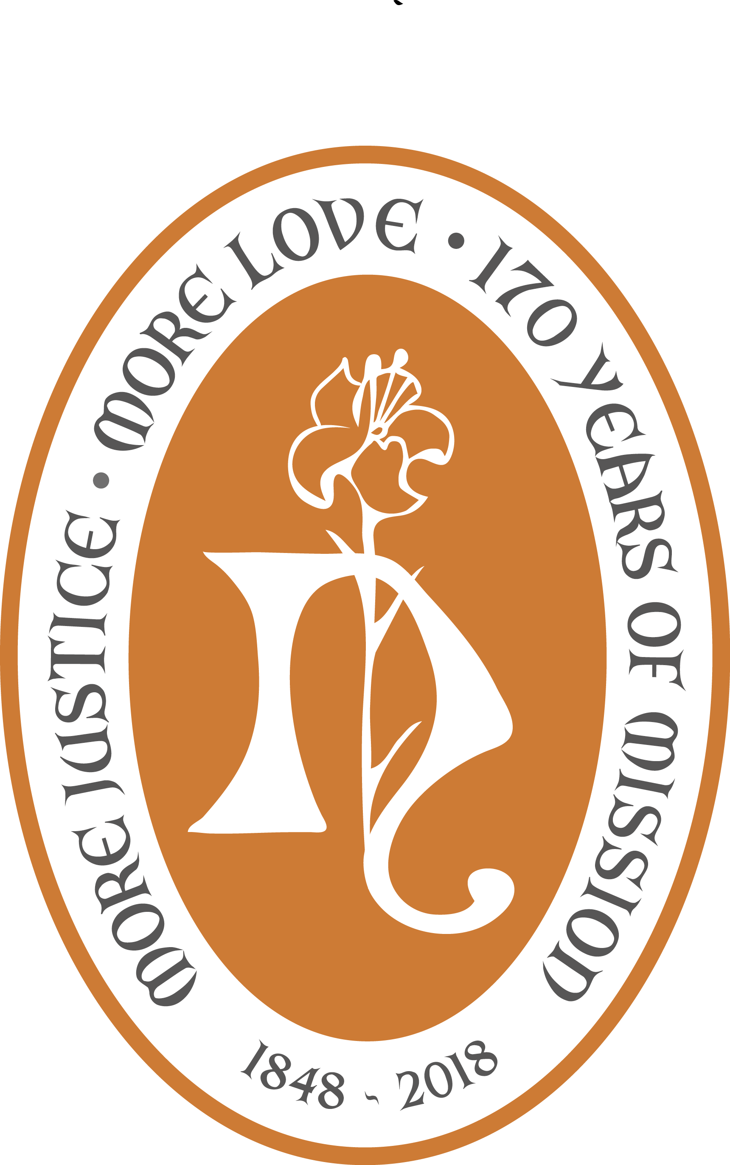

# Priest’s Office, Assisi Centre, Lawford’s Gate, Bristol BS5 0RE tel: 07779677370

# Parish Office, Assisi Centre, Lawford’s Gate, Bristol BS5 0RE tel: 0117-909-0419October

# (Office open: Monday-Friday 10am - 1.00pm)

# ‘Borderlands’ Charity Office: Assisi Centre, St Nicholas Church tel: 0117-904-0479

# Parish email: [bristol.stnicholasoftolentino@cliftondiocese.com](mailto:bristol.stnicholasoftolentino@cliftondiocese.com)

# Fr Richard’s email: [richard.mckay@cliftondiocese.com](mailto:richard.mckay@cliftondiocese.com)

# Clifton Diocesan Website: [www.cliftondiocese.com](http://www.cliftondiocese.com)

# Download this Bulletin from the Parish Website: [www.tolentino.org.uk](http://www.cliftondiocese.com)

# Parish Priest - Rev Richard McKay (tel: 07779677370)

Catechesis: Mary Hopper (01275-830788) Caretaking of our buildings: Eddie Mgbeoduru

Safeguarding Reps: Mary Hopper (01275-830788) & Paul Bradshaw-Price

***Turning the Tables -***

***God’s Upside-down Kingdom***

Who are the nameless ones of today’s world? The victims of hunger dying of famine, victims of war dying of barrel bombs and napalm, victims of the refugee journey to freedom, drowning in the Mediterranean! Countless nameless ones in the world of the poor.

But for God? The nameless one is the man who lost himself in his riches that blind him to human suffering: so stuffed with self and satisfaction with wealth and feasting that he has lost sight of his humanity in not seeing his impoverished brother. In this parable of Jesus, the poor has an honoured name - Lazarus - the name of a friend, while the rich man and self-centred one has no name - is anonymous in the Kingdom.

How different life with Jesus is! He inverts everything. The real question for us and the Church: is it true for us - are we ‘turning the world upside down?’ If not, why not?



Parish Administration & Hall/Room Bookings: Astrid Fagon and Team (0117-909-0419)

***TWENTY-SIXTH SUNDAY Year C - Season of Creation***



**SUNDAY: PARISH SERVICE OF WORD & COMMUNION at 10.00am**  *(Live-streamed)*

**MONDAY:**   ***Feast of Ss Michael, Gabriel and Raphael - Archangels* No liturgy**

**TUESDAY: *Feast of St Jerome, priest and first Biblical Scholar* No Liturgy**

**WEDNESDAY: *Feast of St Therese of Lisieux, Carmelite nun and Teacher* No Liturgy**

**THURSDAY: *Adoration*** at !1.30am **Service of Word & Communion** at 12noon

**FRIDAY: *CAFOD FAMILY FAST DAY - FAST FOR THE POOR OF THE WORLD***

**Adoration** at 11.30am **Mass for Justice** at 12.00noon

**SATURDAY: *Feast of St Francis of Assisi - Patron of Ecology & Peace-makers* Adoration** at 11.30am **Mass** at 12.00noon

***Sacrament of Reconciliation:*** after Mass and 4.00-4.43pm

***28/09/2025*** [1] On the **26th Sunday of Year C** we celebrate Jesus who chooses to be found always among the poorest. The parable of the rich man and Lazarus the poor man tells us where Jesus is found and who it is who is greatest in the Kingdom of God - the poorest! Jesus, Prophet and Saviour of the Poor challenges us to raise up the poor as Lazarus is raised! Do we?

***PRAY FOR THIS WEEK***’***S PARISH MINISTRY OR MISSION*** **28/9/2025** Giving thanks for sisters and brothers in this very ancient Church, going back to the Acts of the Apostles, it is our privilege to host them Sunday by Sunday here at St Nicks**.**

***DIOCESAN PRAYER*** We pray today for the Parishes in Communion for Mission of St Augustine of Canterbury, Downend, Our Lady of Lourdes, Kingswood, St Lawrence, Chipping Sodbury with St Paul, Yate, served by Fr James Williams, Fr Barnabus Page, Deacons Michael Belt, Vincent Calder, Parish Administrators Bernadette Thomson, Maria Fernandez and all their communities

***TWENTY-SEVENTH SUNDAY YEAR C - Season of Creation***

**SUNDAY: PARISH MASS at 10.00am**  *(Live-streamed)*

**Mass with the Catholic Handicapped Fellowship** at 3.00pm - all welcome

**MONDAY:**   **No liturgy**

**TUESDAY: *Feast of Our Lady of the Rosary* No Liturgy**

**WEDNESDAY:**  **No Liturgy**

**THURSDAY: *Feast of St John Henry Newman, Priest & Doctor of the Church* (d 1890) *Adoration*** at !1.30am  **Mass** at 12noon

**FRIDAY: *Feast of St Paulinus - first Bishop of York, monk***

**Adoration** at 11.30am **Mass** at 12.00noon

**SATURDAY: *Feast of St John XXIII, reforming Pope of Vatican II (1881-1963)* Mass** at 8.30am **[change of time because of Diocesan Formation Day)**

***Sacrament of Reconciliation:*** 4.00-4.43pm only

***21/09/2025*** [1] The **27th Sunday nof the Year** celebrates Jesus the Servant, the Divine One in our human flesh, who washes feet and prepares the sacred meal for all humanity. The Lord, the King who comes not to be served but to serve. And he challenges us and the whole Church to be a Servant Church washing the feet of the world’s poorest and so offering redemption to the rich. ‘Lord increase our faith’ so that we will risk truly living the Gospel and find joy in serving. How do we serve?

[2] **Retiring Collection for the CAFOD Harvest Fast Day** - sharing what we have with the poor of the world through our great **‘Catholic Fund for Overseas Development’**

[3] We pray today for **Prisoners, their families, & all who staff our prisons - praying for the reform of Penal System.** We imprison in Britain more people than any other European country, especially more women. And 90% are the poor of our nation!

***THOUGHT FOR 27th SUNDAY YC No Spirit of Timidity!***

For too long we as Catholics have hidden our faith behind our closed doors or in our private convictions: even boasting that our neighbours and friends did not know we are Catholics! Pope Benedict when he visited UK challenged us - fan into a flame that our society can see - the Spirit of Power, Love and Self-Control! We are called to be witnesses, letting Jesus be seen in our lives, identified in our communities and heard in our words. God is always the God who speaks, the God who ‘appears’ in our humanity (in Jesus and in us!). If our society does not know God or experience the joy and fullness of life that is faith in the Living God - then maybe it is in part because we have been too timid in our faith and suppressed the Spirit who gives us the eloquence of faith and prophets!

***DIOCESAN PRAYER*** **5/10/2025** The Diocese prays today for the Parishes in Communion for Mission of St Nicholas of Tolentino, Easton, St Patrick, Redfield and St Joseph, Fishponds served by Fr Richard McKay, Canon Gregory Grant. Fr Jerome, Deacons Denis Deasey and Rob Easton, Parish Assistants Mary Hopper, Amelia Dunford, Parish Administrators Astrid Fagon & Team, Savia Rodrigues, Sara Sampson and all their communities.

***PRAY FOR THIS WEEK***’***S PARISH MINISTRY OR MISSION*** **5/10/2025** We pray today for our **Parish School of St Nicholas of Tolentino**, led by our Head Teacher Mrs Rachael James. Giving thanks for the excellent and hard work of all the staff in educating and caring for our children and the pastoral care of many of our families, we recognise the school as a special part of the Mission of our parish and the wider Church, offering the special contribution of Catholic Christian education to our inner city community with all its diversity. We value children and families of different faiths and beliefs who seek to educate their children with us. We have a number of Muslim families who have chosen our school for their children. **We need a parishioner to join the Governing Body of the school - if interested please approach Richard**

***COLLECTIONS - notication in Bulletin for Sunday 12th October***

GA: £ + Loose £ + Card Reader £ + S.O. £165.88 = £ ***thanks!***

***DATES FOR THE DIARY***

8th Oct Ashley Churches Together Serving (ACTS) meet at 12.30pm Ivy Church

10th Oct Pre-Baptism Course First Session 6.30pm in Assisi Centre

11th Oct Diocesan Formation Day (‘Joyful Evangelists’) St Brendans 9.30am-3.30pm

12th Oct Rite of Child Catechumen at 10.am Mass

17th Oct Pre-Baptism Course Second Session 6.30pm in Assisi Centre

26th Oct Baptismal Sunday at 10.00am Mass

2nd Nov **FEAST OF ALL SAINTS - Mass at 10.00am**

3rd Nov **Commemoration of All the Faithful Departed, All Souls Day mass 7pm**

11th Nov Remembrance Sunday - Praying for Peace with Justice

***ST BERNADETTE’S SECONDARY SCHOOL - OPEN EVENTS*** Thinking about the right Secondary school for your child? Please consider seriously one of our Catholic Schools. Come see what St Bernadette’s offers:

**Open Mornings: Wednesday 1st Oct 9.15-10.45am; Thursday 16th Oct 9.15-10.45am**

***ST BEDE’S CATHOLIC COLLEGE - OPEN EVENING*** Parents and Pupils are invited to view the College at an **Open Evening on Thursday 2nd October at 6.00-8.00pm. Morning visits welcomed throughout then year - by appointment only please.**

***PREPARING FOR YOUR CHILD’S BAPTISM*** Parents seeking the baptism of their children are asked to inform Eustace Tameh or Christopher and Epiphania Chipato or Fr Richard as soon as possible. Next Baptism course and celebration:

**BAPTISMAL SUNDAY 26h OCTOBER** at 10am Mass

**Preparation Sessions**: Friday 10th and 17th October at 6.30pm (Assisi Centre)

**Rite of Child Catechumen** **Sunday 12th October** at 10am Mass

***THREADS THROUGH CREATION - Spectacular display of Textile Art***  A powerful exhibition of textiles and tapestries depicting Creation in the Scriptures. Having visited this remarkable exhibition, I thoroughly recommend all who can to visit it, especially in this ‘Season of Creation’. At Victoria Methodist Church, Whiteladies Road, Bristol 25th August to 4th October. Free Entry Monday/Wednesday/Friday 11am - 4pm ; Tuesday/Thursday/Saturday 11am-6pm

***PRAYING FOR PEACE IN SOLIDARITY WITH HOLY FAMILY CHURCH IN GAZA*** There is a movement inviting us all to pray in solidarity with the beleaguered Catholic Church in Gaza (Holy Family Church - Pope Francis and now Pope Leo phones them regularly). Pray together the Rosary for Peace at or around 7.00pm each Monday evening also supporting spiritually the small Catholic community who are still caring for 450 displaced people in their precinct. Please respond to the call to prayer

***‘GOING THE DISTANCE’*** - an evening session to support vibrant and lasting marriage organised by the ecumenical ‘Care for the Family’ charity. Held on **23rd October at 7.30pm at the OTHER St Nicholas Church, BS1 1UE - NOT here at St Nicholas of Tolentino.** Early bird ticket £6.00 (until 23 Sept), after that Couples ticket £22, single ticket £11. contact ***[www.cff.org.uk/goingthedistance](http://www.cff.org.uk/goingthedistance)*** or 029 2081 0800

***DIOCESAN FORMATION DAY - 11th OCTOBER at ST BRENDAN’S COLLEGE*** Come together as a diocesan family to reflect on the theme - ‘***Being an Evangelist today: the tools required to be a joyful witness of Jesus’***. Keynote speaker Mgr John Armitage (formerly Rector of Our Lady of Walsingham Basilica - our National Shrine). 9.30am-3.30pm bring your lunch. book ***[diocesanformationday.eventbrite.co.uk](http://diocesanformationday.eventbrite.co.uk)***