Mass for the Patronal Feast of
St Nicholas of Tolentino
concluding our 170th Anniversary Year

ENTRANCE LITURGY

PROCESSIONAL SONG African
ENTRANCE HYMN No 458

AT THE BAPTISMAL FONT - Renewal of Baptismal Promises

RICHARD: As we conclude our celebration of 170 years of mission and witness, we recommit ourselves to God’s future for our parish of community and mission. Baptism is the foundation of our Life in Christ. Signed by the Cross of Christ and immersed in the Sacred Waters, we die to ourselves and rise with Christ, to live for Him, for each other and for our world; from the Fount of Living Water we drink deeply of the Holy Spirit, and cry out ‘Abba! our Father!’. From every tribe and nation, race and people we are gathered into the one Family of all God’s Children.

EUSTACE: Will you now renew your commitment as the People of the Water:
Do you renounce all evil in the world and in your own hearts?
Do you commit yourselves to living the holiness of the Beatitudes?

PEOPLE: We do renounce all evil, seeking to live the Holiness and Love of Christ.

MARGARET: Will you love God your Father with all your heart and strength?
Will you accept afresh the New Life won for you
by the Death and Resurrection of Jesus Christ, brother to all Humanity?
Will you open afresh your life to the Power and Gifts of the Spirit that we might continue the Mission of the Church here long into the future?
Will you live faithfully as a member of God’s Holy Church,
building together a Universal Communion of love for all the nations?

PEOPLE: Signed by the Cross of Christ, we will live our Baptism in love for the Father, the Son and the Holy Spirit in the heart of the Church.

RICHARD: Divine Trinity, bless anew the water of this Font
and renew the Grace of Baptism in each member of this Parish. Empower us for our mission: to build our community in love and service
and so witness to the love of Christ in the heart of the Inner City,
In the Name of the Father, + the Son and the Holy Spirit...

PEOPLE: AMEN!

All are sprinkled with Baptismal Water as a sign that we seek to live our Baptism anew.
MEANWHILE ALL SING No 407

GLORIA African Gloria
OPENING PRAYER
LITURGY OF THE WORD

AT THE LECTERN - Rededication to the Word African Song of Acclamation
The Books of the Word are brought to the Lectern, ‘the Table of the Word’. Our priest and Readers go to the Lectern to welcome the Books of the Holy Scriptures, and all rededicate ourselves to the Word Who is Life for us, Bread for our Journey.

RICHARD: Our God is the One who speaks - a Word that creates, redeems and heals.
God speaks with such intensity that the Word was made Flesh in Jesus.
This Living Word is to be proclaimed in new ways
by this parish for years to come.
Let us always open our hearts to the Word Who is Life,
that the flesh of our lives will also carry the Word to the World.

MARY: Will you rededicate yourselves to being the People of the Word?
Will you allow the Word to gather you as one community?
Will you welcome the Word when it challenges you to change?
Will you, like Mary, ponder the Word in your heart and make it your treasure
and like St Nicholas build your lives upon the Rock of God’s Word?

PEOPLE: WE REDEDICATE OURSELVES TO BEING BOTH LISTENERS
AND DOERS OF THE WORD, PROCLAIMING THE GOSPEL WITH OUR LIVES SO THAT THE WORD WILL BE MADE FLESH IN US.

FIRST READING Jeremiah c1: vv 4-10
RESPONSORIAL PSALM No 892
SECOND READING Romans c8: vv 14-25
GOSPEL ACCLAMATION African
GOSPEL Luke c4: vv 16-21
HOMILY

RENEWAL OF COVENANT WITH THE POOR

RICHARD: As in the past, so into the future God entrusts to our parish the care
of the poor of the city. The Holy Spirit calls and empowers us to rededicate ourselves as a community to that same caring for the poor and marginalised, excluded and rejected. Challenged to work for a True Jubilee of Justice and Peace for our world by remaining true of our Covenant with the Poor.,
and inspired by God’s great Lover of the Poor, St Nicholas,
we accept again the challenge of our Jubilee 2000 Covenant:
to hold in prayer the poor and conflict-torn of the world;
to recognise the causes of poverty, war and racial conflict and so campaign;
to find renewed energy for inspired action to bring about peace and justice;
to welcome the stranger among us and struggle with them for freedom.
Do you reaffirm this Covenant with the Poor?

People: WE REAFFIRM OUR PARISH COVENANT WITH THE POOR:
WE WILL CONTINUE TO REACH OUT IN COMPASSION TO THE POOR
OF OUR STREETS AND CITY, WELCOMING & LISTENING TO THE STRANGER;
WE REDEDICATE OURSELVES AND OUR PARISH TO THE STRUGGLE
FOR JUSTICE AND EQUALITY FOR ALL THE PEOPLES OF THE EARTH.
INTERCESSIONS - AFTER EACH INTERCESSION, ALL SAY

RENEW YOUR PEOPLE IN LOVE…

LITURGY OF THE EUCHARIST

OFFERTORY No 473, then the Consecration of our Icon of St Nicholas and the Blessing of the St Nicholas Bread (during Incensing) chant ‘Laudate Omnes Gentes’

EUCHARISTIC ACCLAMATION
Sanctus: No 559
Consecration: No 560
PEACE No 922

COMMUNION No 245 (‘Ubi Caritas’)
African Song,
No 882

AT THE TABLE OF THE EUCHARIST Rededication as the Community of the Bread and the Cup
After sharing the Eucharist together, the Clergy stand once more at the Altar Table and lead us in an Act of Rededication as the People of the Eucharist.

RICHARD: At the centre of every Catholic church stands the Table of the Lord.
May generations to come gather around this Eucharistic Table
to share the Breaking of the Bread, and to drink deeply
of His transforming love in the One Cup.
The Eucharist is the Sacrifice of Christ that has broken down the barriers
dividing us from each other; it is the centre of our lives,
the love that gathers us from every race, culture and language
into a Universal Community, a People of joyous diversity, the People of God;
the power which nourishes us and sends us in mission to our world.

SAM: Will you commit yourselves afresh to being the People of the Eucharist, working in the years and decades that lie ahead of us as a parish
for the unity of the One Bread and One Cup
among yourselves and with Christians of every tradition?
Will you commit yourselves afresh to being the People of the Eucharist, to break bread of justice, share the cup of suffering with the poor,
welcome the stranger and the outcast to our Table
and bring healing to our divided society?

PEOPLE: WITH GRATEFUL HEARTS WE WILL BECOME THE LIVING
EUCHARIST IN THE HEART OF THE WORLD, SERVING UNITY.

BRICE: Will you commit yourselves afresh to being the People of the Eucharist,
by hungering for Christ’s presence and thirsting for Christ’s love ...
by expressing that love by humble service of the poor and broken
of your world?

PEOPLE: WITH GRATEFUL HEARTS WE WILL DEEPEN OUR LOVE
FOR CHRIST, WHO WASHED OUR FEET AT THE FIRST EUCHARIST AND TOLD US TO DO LIKEWISE.

LITURGY OF BLESSING AND MISSION

THE BLESSING AND MISSION
Commissioning and Sending our Community for another year of Service and Witness to the Lord

RECESSIONAL No 854

Thank you for coming to celebrate this very special celebration of our Patronal Feast, marking the conclusion of our 170th anniversary year and the beginning of a new era in the life and mission of our parish community. We have been nourished by the remarkable witness of St Nicholas of Tolentino and celebrated our identity as a parish of diverse peoples called together by God here in the Inner City. Rededicating ourselves to the work of the Kingdom in the years and decades to come, may we embrace every new challenge that the future holds and be a community in Christ that is Re-Born in love’s obedience to His Word, ready again to continue building this One World in His Justice, Equality and Peace.

Please go to the School Hall to share the St Nicholas Bread and then our Multi-cultural Lunch, and to share song, dance and other gifts with each other.

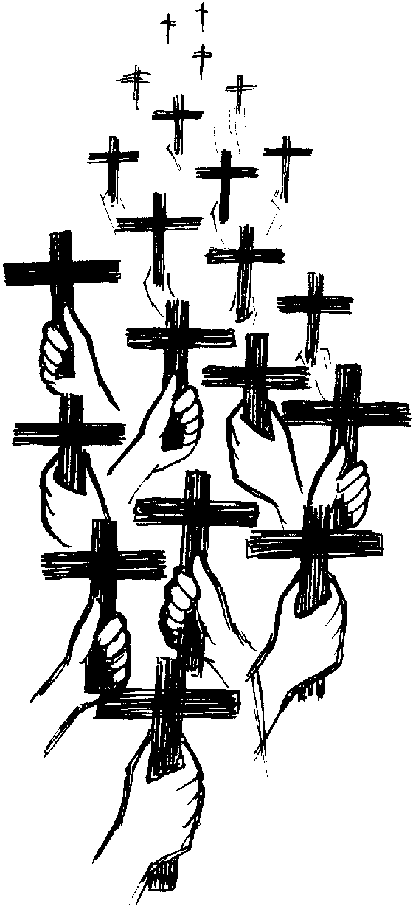

LITURGY OF BLESSING AND MISSION

RICHARD: We stand in a rich tradition of 170 years of faith and prayer,
witness and service ...
may the Father make us faithful
to all that has been handed on to us

PEOPLE: AMEN!

RICHARD: Jesus shares with us His dream of a world made new,
a New Heaven and New Earth where all creation is set free.
May we listen to his call, walk his Way, proclaim His Truth
and give Life by His Love
in new and challenging ways

PEOPLE: AMEN!

RICHARD: May the Holy Spirit, fall upon us ...
with life-giving Water to cleanse and heal;
with Fire to burn love into our hearts;
with Mighty Wind to empower us to be Prophets
that we will be a Parable of Communion in the Inner City
forging the future with new courage

PEOPLE: AMEN!

RICHARD: May Almighty God bless us all
Father + Son and Holy Spirit
now and forever ...

PEOPLE: AMEN!

RICHARD: Our Celebration is ended ...
go in the love of God,
the Freedom of Christ
and the power of the Spirit
to proclaim the Risen Christ

PEOPLE: THANKS BE TO GOD!

